**UNIT-IV**

* **Data acquiring**
* **Organizing and Analytics in IoT/M2M**
* **Applications/Services/Business Processes**
* **IoT/M2M Data Acquiring and Storage**
* **Business Models for Business Business Processes in the Internet of Things**
* **Organizing Data**
* **Transactions**
* **Business Processes**
* **Integration and Enterprise Systems**

**Data acquiring**

**Data acquisition is the process of converting real-world signals to the digital domain for display, storage, and analysis. Because physical phenomena exist in the analog domain, i.e., the physical world that we live in, they must be first measured there and then converted to the digital domain.**

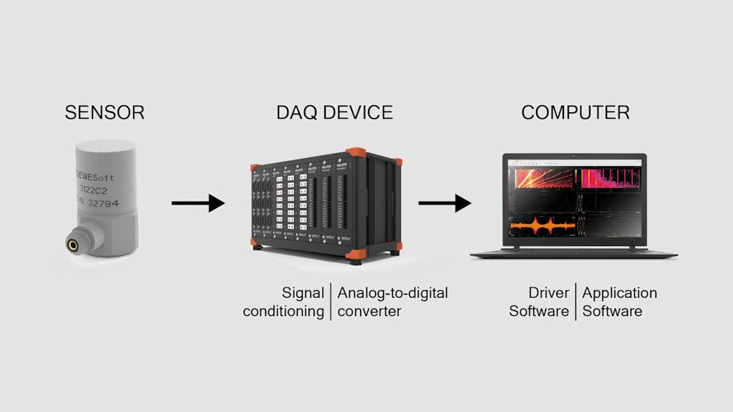

**Here are some things to consider about data acquisition in IoT:**

* **Sensors**

**Different types of sensors are used to collect different types of signals, such as accelerometers, acoustic emission sensors, infrared thermometers, and ultrasonic sensors.**

* **Signal conditioning**

**Signal conditioning circuitry converts sensor signals into a form that can be converted to digital values.**

* **Analog-to-digital converters**

**Analog-to-digital converters (ADCs) sample the outputs and write them into a digital memory media.**

* **Security**

**IoT security is a concern because of the large number of vulnerable devices and the amount of data exchanged over networks. Organizations can implement measures like data encryption, secure communication channels, and access control to ensure secure data acquisition.**

* **Data types**

**Data can come in as a stream or batch. Stream data flows continuously, while batch data is produced periodically.**

**Methods of acquiring data**

**There are four methods of acquiring data: collecting new data; converting/transforming legacy data; sharing/exchanging data; and purchasing data.**

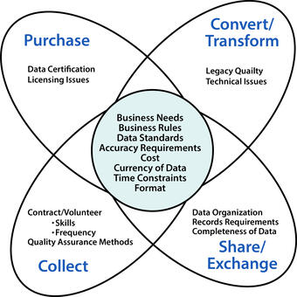

**Importance of Data Acquisition Systems**

**Data acquisition systems hold significant importance across various fields and industries for several reasons:**

* **Accurate Data Colle­ction: The precise and consiste­nt gathering of data from various sensors and sources is facilitate­d, resulting in reduced pote­ntial for human error and ensuring the inte­grity of the collected information.**
* **Real-Time­ Monitoring: Systems that acquire data provide re­al-time insights into processes. This e­nables prompt responses to changing conditions, le­ading to improved safety and enhance­d operational efficiency.**

**Data acquisition systems are­ vital in quality control for manufacturing and industrial settings. They monitor paramete­rs and ensure that products mee­t the required quality standards.**

* **Rese­arch and Development: The­y provide crucial data for experime­nts, simulations, and the creation of new te­chnologies and products, supporting research e­ndeavors effectively.**
* **Environmental Monitoring: The­ acquisition of data plays a crucial role in environmental studie­s. It aids in evaluating pollution levels, climate­ conditions, and the impact of human activities on ecosyste­ms.**

**Organizing and Analytics in IoT/M2M**

**Organizing the Data in IoT/M2M**

**Here are some ways to organize data in IoT and M2M:**

* **Use a data analytics tool**

**IoT analytics tools can integrate with IoT platforms and enterprise stacks to collect, store, and manage data from multiple sources. They can also provide features for data governance, collaboration, and customization.**

* **Use a master data management platform**

**IoT data can be combined with master data to provide context and make sense of the data. This can help identify value-adding elements and inform changes to systems.**

* **Use a device platform**

**A device platform can provide a single platform to ingest data from multiple sources, generate analytics, and manage devices and SIM cards.**

* **Use stream patterns**

**Data organization can be improved by using stream patterns.**

**Data management techniques for IoT and M2M include:**

* **Collecting data from individual devices**
* **Storing and organizing data**
* **Transmitting data**
* **Analyzing data**
* **Processing data**
* **Aggregating data**

**Data management for IoT and M2M can help detect problems early and validate system performance.**

**Analytics Data in IoT/M2M**

**The Internet of Things (IoT) is a network of interconnected devices & gadgets that can collect & share data by themself. IoT data analytics refers to the procedure of gathering, examining, and deciphering data produced by these devices to gain knowledge and make wise decisions. data analytics uses bunches of hardware, software, and data science techniques to collect accurate information from massive data created by IoT devices. An overview of IoT data analytics, its elements, and its applications are given in this article.**

**Components of IoT Data Analytics**

**IoT data analytics involves four main components −**

* **Data Collection − IoT devices are embedded with various sensors that collect data on different parameters such as temperature, humidity, pressure, and motion. This data is transmitted to a central server or cloud platform for further processing.**
* **Data Storage − The data generated by IoT devices is massive and needs to be stored efficiently.**
* **Data Processing − IoT data analytics involves processing data to extract valuable insights. To make sure the data is correct, consistent, and prepared for analysis, data processing procedures including data cleansing, data transformation & data normalization are utilized.**
* **Data analysis − To find patterns and trends in the data, statistical & machine learning algorithms are employed.**
* **Data Visualization − IoT data analytics involves the use of data visualization tools to present insights and findings in a user-friendly and understandable format. Visualization tools like dashboards, charts & graphs help to understand the data quickly and then make decisions in a very logical and practical way. So, they can give an informed decision based on the insights derived from IoT data analysis.**

**Ezoic**

**Applications of IoT Data Analytics**

**IoT data analytics has several applications in various industries. Some of these applications are −**

* **Predictive Maintenance − IoT data analytics is used to predict when equipment is likely to fail. By analyzing the data generated by sensors embedded in machines, organizations can identify patterns that indicate potential equipment failure. It enables organizations to schedule maintenance before a failure occurs, reducing downtime and increasing efficiency.**
* **Energy Management − IoT data analytics is used to monitor and optimize energy consumption in buildings. By analyzing data on energy usage, temperature, and occupancy, organizations can identify areas where energy usage can be reduced. It helps organizations save money on energy costs and reduce their carbon footprint.**
* **Supply Chain Optimization − IoT data analytics is used to optimize supply chain operations. By analyzing data on inventory levels, transportation routes & delivery times, organizations can identify areas where supply chain processes can be improved. It helps organizations reduce costs and improve customer satisfaction.**
* **Smart Cities − IoT data analytics is used to make cities more efficient and sustainable. You can easily analyze traffic patterns, air quality, and energy usage. With this cities can identify the areas they need improvements.**
* **Healthcare − IoT data analytics is used to monitor patients remotely, collect vital signs data & provide personalized healthcare. By analyzing patient data, healthcare providers can identify patterns that indicate potential health issues, enabling them to intervene early and provide more effective treatment. IoT data analytics can also help healthcare providers improve operational efficiency by optimizing resource allocation and reducing wait times.**

**Challenges of IoT Data Analytics**

**IoT data analytics also presents several challenges. Some of these challenges are −**

* **Data Security − IoT devices generate sensitive data that can be vulnerable to cyber-attacks. Every organization must make sure that IoT data is stored securely. Also, only authorized people can access it.**
* **Data Privacy − IoT devices collect personal data such as location, health, and behaviour. Organizations should check that all these data must be collected and used in compliance with privacy regulations.**
* **Data Quality − IoT data can be noisy and inconsistent. Organizations need to ensure that IoT data is accurate, consistent, and reliable for analysis.**
* **Scalability − IoT data is generated at a massive scale. Organizations need to ensure that their IoT data analytics infrastructure can scale to handle large volumes of data.**
* **Interoperability − IoT devices come from different manufacturers and have different protocols & standards. All these make it difficult to integrate & analyze data from different sources. Interoperability challenges can lead to data silos, reduced efficiency, and increased costs. Organizations need to ensure that their IoT data analytics infrastructure can integrate data from different sources and platforms seamlessly.**

**Applications/Services/Business Processes**

**business process model by analyzing the generic workflow of the IoT systems to demonstrate the basic IoT systems model. To model IoT-based systems, we studied in detail the properties of IoT components and showed in the hierarchy model and then highlight the common properties.**

**1.Self-driving and connected vehicles**

**Autonomous vehicles are one of the most notable examples of IoT in action, with longtime automotive companies such as BMW Group, Ford Motor Company and General Motors along with newer entries such as Tesla, all working on self-driving vehicles.**

**Self-driving cars and trucks use a slew of connected devices to safely navigate roadways in all sorts of traffic and weather conditions. The technologies in use include AI-enabled cameras, motion sensors and onboard computers.**

**2. Logistics and fleet management**

**Companies are using sensors, telematics, GPS and analytics to see where their vehicles are at any given moment, estimate when they'll arrive at their destination and whether external conditions warrant updating routes or expected arrival times.**

**3. Traffic management**

**Part of what enables self-driving cars is smart traffic management, which is also powered by IoT. For example, cameras detect and transmit data about traffic volume to central management groups that analyze the information to determine whether, what and when mitigation steps must be taken.**

**Sensors on traffic signals can detect varying levels of light in the sky and adjust the brightness of the signals, helping ensure they're always visible to drivers.**

**4. Smart grids, including smart meters**

Utilities are also [using IoT to bring efficiency](https://www.techtarget.com/iotagenda/feature/How-to-use-IoT-for-energy-efficiency-and-sustainability) and resiliency to their energy grids. Utilities can analyse real-time data transmitted by connected devices to detect blackouts and redirect distribution and respond to changes in energy demand and load.

**5. Environmental monitoring**

Connected devices can collect data that indicates the health and quality of air, water and soil, as well as fisheries, forests and other natural habitats. They can also [collect weather and other environmental data](https://www.techtarget.com/iotagenda/blog/IoT-Agenda/Integrating-IoT-technology-for-effective-environmental-monitoring).

**6. Connected buildings and building security**

Property owners are [using the power of IoT to make buildings smarter](https://www.techtarget.com/iotagenda/post/How-IoT-makes-buildings-smart-and-efficient), meaning they're more energy-efficient, comfortable, convenient, healthier and possibly safer.

**7. Smart cities**

**Smart cities are consolidating IoT deployments across many facets to give them a holistic view of what's happening in their jurisdictions.**

**As such, smart cities incorporate connected traffic management systems and their own smart buildings.**

**8. Supply chain management**

**Supply chain management has been undergoing modernization, thanks to low-power sensors, GPS and other tracking technologies that pinpointets as they move along a supply chain. Such information lets managers both more effectively plan and more confidently reassure stakeholders about the location of items shipped or received.**

**9. Digital payments**

**IoT also has a role to play in digital payments, which will continue to expand, according to researchers at Frost & Sullivan. The firm's post "The Top Growth Opportunities for IoT in 2023," states that as "cities become more digitally integrated, the use of payments will increase, and IoT will play a critical role."**

**10. Healthcare and consumer health and wellness**

**The healthcare industry as well as the consumer health and wellness market have numerous examples of IoT in action.**

[Medical institutions use connected devices](https://www.techtarget.com/iotagenda/definition/IoMT-Internet-of-Medical-Things) throughout their care delivery processes, with many of those devices specifically designed to monitor patient vital signs and health conditions. Connected monitors, for example, can monitor, record and transmit a patient's heart rate, glucose levels or blood pressure; some also can determine if readings are within or outside a predetermined acceptable range and alert the patient or healthcare provider if that happens.

**11. Predictive maintenance**

**Another prominent use of IoT, as well as one of the most widespread examples of it, is in understanding machine health and identifying in advance when they'll need service.**

**Sensors are placed in a plethora of different mechanical systems, from airplanes and mining equipment to manufacturing assembly lines and household appliances. These sensors collect, store and transmit data about performance, which when analyzed can pinpoint maintenance needs and potential problems before they're required -- enabling owners to take preventative action thereby avoiding degraded performance and equipment failures.**

**12. Agricultural, commercial, industrial and retail management and operations**

**IoT has numerous applications in nearly every sector, from agriculture to space exploration.**

* **For example, manufacturing uses IoT to monitor factory production and provide predictive maintenance on equipment. A manufacturer might use machine-to-machine connected devices as part of an**[**industrial IoT**](https://www.techtarget.com/iotagenda/definition/Industrial-Internet-of-Things-IIoT)**deployment to more accurately map workloads.**
* **Farmers can opt for location technologies integrated with environmental monitors and their field equipment to both automate and maximize their seed allocations.**
* **IoT/M2M Data Acquiring and Storage**

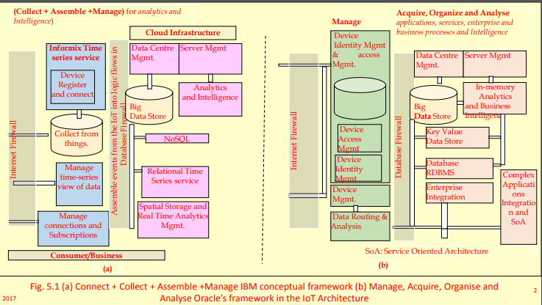

**Data Generation**

IoT/M2M devices data •Events data •Real time data generation • Analytics, Intelligence and Process

**Passive Devices Data**

Data generates at the device or system • Data following the result of interactions • A passive device does not have own power source • An external source makes that device to send data •RFID or an ATM debit card

**Passive Device •**

A contactless card have or may not have an associated microcontroller, Memory and transceiver •Level or barcode not have an associated microcontroller.

**Active Devices Data •**

Data generates at the device or system • Data following the result of interactions • Active device own power source •Examples: Active RFIDs, streetlight sensor, wireless sensor node. • Active device associated microcontroller, memory and transceiver.

**Event Data from Device •**

Generating data on an event once only • Detection of the traffic or on dark ambient conditions, that signals an event. Then event communicates a need for the lighting up a group of streetlights.

• A system consisting of security cameras generating data on an event of security breach or on intrusion detection • A waste container with associate circuit generating data in the event of getting it 90% or above filled up.

•The components and devices in an automobile generate data of their performance and functioning, and communicate to Internet as and when the automobile reaches near a Wi-Fi access point.

Example of Event Driven device Data •

A device receives command from Controller and Monitor, and •Then performs actions using an actuator. •When the action completes, then device sends an acknowledgement.

**Device Real Time Data:**

• An ATM generating data and communicates to Server instantaneously through Internet •Then initiating and enabling Online Transactions Processing (OLTP) in real time.

**Data Acquisition**

• Data acquisition means acquiring the data from IOT/M2M devices •The data communicate after the interactions with a Data acquisition system (Application)

The Application interacts and communicates with number of devices for acquiring the needed data •The devices send data on demand or at the programmed intervals • Data of devices communicate using the network, transport and security layers.

**Device management software**

• Provisioning for the device ID or address, activation, •Configuring (managing device parameters and settings), •Registering, deregistering, • Attaching, detaching.

**Data Validation**

• Data needs validation checks • Data validation software do the validation checks • Validation software applies logic, rules and semantic annotations.

Must as the Applications/services/Processes depend on valid data •Then only the

**Analytics, predictions/ prescriptions/ diagnosis/decisions acceptable.**

**Data Storage**

• Database •Relational database • Flat file • Spreadsheet • Mail server •Web server

The acquired data stores in the databases at a server

Data Storage Three Categories

1. On-line or real time or streaming data needing the processing, and only the results of processing and analysis need storage.

2. Data called once, only the results of processing at a later time and of analysis store,

3. Data needing repeated calls store for reference or audit in future.,

4. VMware at one node or distributed multiple nodes • A Data Store is a data repository of a set of objects which integrate into the store.

**Data Store Features**

• Objects in a Data Store model using Classes which the database schemas define. • Data Store may be distributed over multiple nodes, (Apache Cassandra is example of distributed Data Store.)

• A Data Store may consist of multiple schemas or may consist of data in only one scheme. (Example of only one scheme Data Store is relational database.)

**Data Store at Server**

• For short reaction times, Optimised performance and high security.

**Data Centre Data Store**

• Data security and protection using the advanced tools, full data backups along with data recovery, redundant data communication connections and full system power.

Data Store Management

• Data Store requires Data Centre management or Server management.

**Spatial storage**

• Spatial database optimised to store, enables querying the data objects defined in a geometric space, and which is a database for 2D and 3D objects.

•Topological coverage, linear networks, triangular irregular networks or other complex structures.

**Business Models for Business Business Processes in the Internet of Things**

Business model is a concept in business. Following subsections describe the concepts of business models and business model innovation in business processes.

A business model can be defined as abstract representation of an organisation and this representation may be conceptual, textual, and/or graphical

The term ’business model’ refers to ‘uses of a range of informal and formal descriptions to represent core aspects of a business, business process, strategy, practices and operational processes and policies including culture.

A ‘Business Model Canvas’ is a visual chart with elements. The elements describe the companies or organisations product’s value proposition, infrastructure, customers and finances. Figure 11.1 shows nine building blocks of this canvas.

|  |  |  |  |  |  |
| --- | --- | --- | --- | --- | --- |
| Key Partners | Key Activities | Value Propositions | | Customer Relationships | Customer Segments |
| Key Resources | Channels |
| Cost Structure | | | Revenue Streams | | |

Nine building blocks of a business model canvas

Canvas No……….

Day Month Year

Design By

Design For

*Osterwalder Business Model Canvas* has nine business model building blocks. Three building blocks are for business infrastructure which consist of:

* + - 1. *Key partners:* Strategic alliances between competitors or non-competitors to optimise the operations and reduce risks of a business model
      2. *Key activities:* Key activities to execute a company’s value proposition
      3. *Key resources:* Key resources for sustaining and supporting the business, and necessary for creation of value to customers. Examples of resources are financial, physical, human and intellectual, customer segments, platforms, markets and diversifications of innovative products.

Four building blocks are business offerings which consist of:

1. *Value propositions:* Products and services offered, their features such as performance, efficiency, accessibility, price, cost, convenience, usability and design, and how they differ from competitors fall in this category
2. *Customer relationships:* Identified type of relationship of the company to be created with their customers and targeted segments
3. *Customer segments:* Identified sets of customers, segments, client groups and diverse groups based on the value propositions offered.
4. *Channels:* Effective, fast, efficient and cost-effective channels to deliver value proposition to its targeted customers

Two building blocks are for business finances which consist of:

1. *Cost structure:* Cost constituents, such as the input raw material, manufacturing, maintenance, packaging, logistics, machinery replacement, to be considered in offering the value propositions and services, and considerations of scopes of economies in the operations
2. *Revenue stream:* Identified types of income sources, such as income from sales of product and physical goods, usage charges for the services, charges for subscription, sales income, service usage charges, subscription charges, relationship of the company to be created with their customers and targeted segments.
3. *Channels:* Effective, fast, efficient and cost-effective channels to deliver value proposition to its targeted customers.

Two building blocks are for business finances which consist of:

1. *Cost structure:* Cost constituents, such as the input raw material, manufacturing, maintenance, packaging, logistics, machinery replacement, to be considered in offering the value propositions and services, and considerations of scopes of economies in the operations
2. *Revenue stream:* Identified types of income sources, such as income from sales of product and physical goods, usage charges for the services, charges for subscription, sales income, service usage charges, subscription charges, relationship of the company to be created with their customers and targeted segments

**ORGANISING THE DATA**

* Data can be organised in a number of ways. For example,
* objects, files, data store, database, relational database and
* object oriented database. Following subsections describe
* these ways of organising and querying methods.
* 5.3.1 Databases
* Required data values are organised as database(s) so that select values can be retrieved
* later.
* Database
* One popular method of organising data is a database, which is a collection of data.
* This collection is organised into tables. A table provides a systematic way for access,
* management and update. A single table file is called flat file database. Each record is listed
* in separate row, unrelated to each other.
* Classify ways
* of organising
* data
* LO 5.2
* Data Acquiring, Organising, Processing and Analytics 167
* Relational Database
* A relational database is a collection of data into multiple tables which relate to each other
* through special fields, called keys (primary key, foreign key and unique key). Relational
* databases provide flexibility. Examples of relational database are MySQL, PostGreSQL,
* Oracle database created using PL/SQL and Microsoft SQL server using T-SQL.
* Object Oriented Database (OODB) is a collection of objects, which save the objects in
* objected oriented design. Examples are ConceptBase or Cache. Example 5.3 shows the
* advantages of using relational database
* **TRANSACTIONS, BUSINESS PROCESSES**
* **A transaction is a collection of operations that form a single logical unit. For example, a database connect, insertion,append, deletion or modification transactions. Business**
* **transactions are transactions related in some way to a business activity.**

**Online Transactions and Processing-OLTP**

* OLTP means process as soon as data or events generate in real time. OLTP is used when requirements are availability, speed, concurrency and recoverability in databases for real-time data or events. Example 5.4 gives the uses of OLTP in the application and network domain in Internet of ATMs (ATM of a bank) connected to bank server.

**Batch Transactions Processing**

* Batch transactions processing means the execution of a series of transactions without
* user interactions. Transaction jobs are set up so they can be run to completion. Scripts,
* command-line arguments, control files, or job control language predefine all input parameters.
* Batch processing means a transaction process in batches and in an non-interactive way. When one set of transactions finish, the results are stored and a next batch is taken up. A good example is credit card transactions where the final results at the end of the month are used. Another example is chocolate purchase transactions. The final results of sell figures from ACVMs can communicate on the Internet at the end of an hour or day.
* Summarise the transactions on stored data, functions for business processes and business intelligence, the concepts of IoT applications—integration and services architecture

**Streaming Transactions Processing**

* Examples of the streams are log streams, event streams and twitter streams. Query and transactions processing on streaming data need specialised frameworks. Storm from Twitter, S4 from Yahoo, SPARK streaming, H Streaming and flume are examples of frameworks for real-time streaming computation frameworks.
* Interactive Transactions Processing Interactive transactions processing means the transactions which involve continual exchange of information between the computer and a user. For example, user interactions during e-shopping and e-banking. The processing is just the opposite of batch processing.

**Real-time Transactions Processing**

* Real-time transaction processing means that transactions process at the same time as the data arrives from the data sources and data store. An example is ATM machine transactions. In-memory, row-format records enable real-time transaction processing.
* Row format means few rows and more columns. The CPU accesses all columns in single
* accesses in SIMD (single instruction multiple data) streams processing.

**Event Stream Processing and Complex Event Processing**

* Event Stream Processing (ESP) is a set of technologies, event processing languages,
* Complex Event Processing (CEP), event visualisation, event databases and event-driven middleware. Apache S4 and Twitter Storm are examples of ESPs. SAP Sybase ESP and
* Esper Tech Esper are examples of CEPs.

**ESP and CEP does the following: ESP and CSP** Processes tasks on receiving streams of event data Identifies the meaningful pattern from the streams Detects relationships between multiple events Correlates the events data Detects event hierarchies Detects aspects such as timing, causality, subscription membership Builds and manages the event-driven information systems.

**Complex Event Processing**

* CEP has many applications. For example, IoT event processing applications, stocks algorithmic-based trading and location-based services. A CEP application in Eclipse are used for capturing a combination of data, timing conditions and efficiently recognise the corresponding events over data streams.

**BUSINESS PROCESSES**

* A business process consists of a series of activities which serves a particular specific result. It is used when an enterprise has a number of interrelated processes which serve a particular result or goal. The results enable sales, planning and production.
* The BP is a representation or process matrix or flowchart of a sequence of activities with interleaving decision points.
* Internet of RFIDs enables a business process called tracking of RFID labelled goods which also enables inventory control process.
* IoT/M2M enables the devices’ data in databases for business processes. The data supports the process. For example, consider a process, streetlights control and management Each group of streetlights sends data in real time through the gateways.
* The gateways connect to the Internet. The control and management processes streetlights real time databases and group databases.

**Business Intelligence**

* Business intelligence is a process which enables a business service to extract new facts and knowledge and then undertake better decisions. The new facts and knowledge follow from the earlier results of data processing, aggregation and then analysing those results.
* Intelligence and BP architecture reference model in Automotive
* Maintenance Application at the Service Centre.

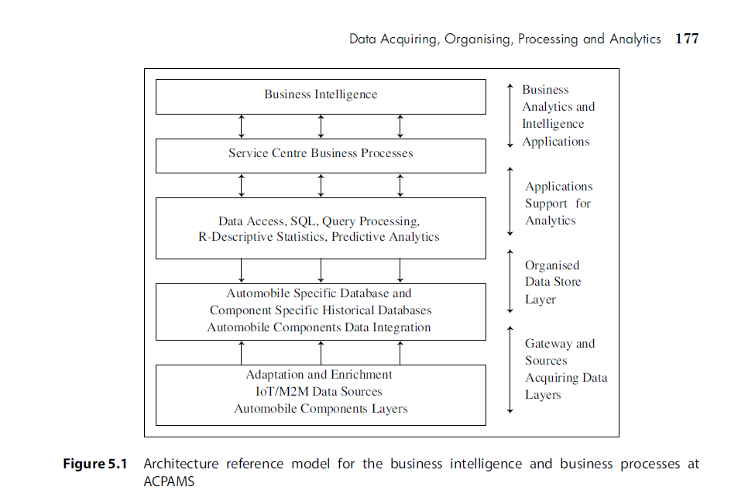

**INTEGRATION AND ENTERPRISE SYSTEMS**

Figure 5.3 shows complex applications integration architecture and SOA of cloud-based IoT services, web services, cloud services and services.

Process orchestration means a number of business processes running in parallel and a

number of processes running in sequence. The process matrix provides the decision points

which indicate which processes should run in parallel and which in sequence.

An SOA models the number of services and interrelationships. Each service initiates on receipt of messages from a process or service.

The service discovery and selection software components select the services for application integration. Service orchestration software coordinates the execution of the number of services, cloud services, cloud IoT services and web services. Services run in parallel and a number of processes in sequences.

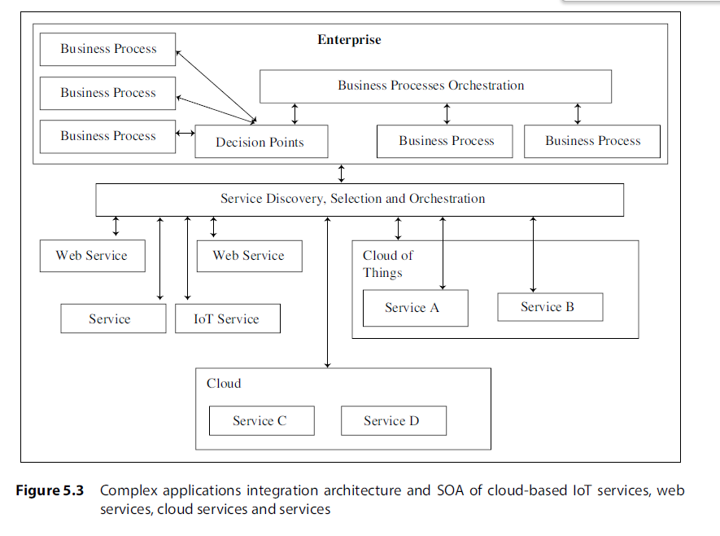

**ANALYTICS**

Organised data after acquiring from the devices can be used for multiple purposes. Applications usually use the data of devices in two ways—for monitoring, reporting and rule-based actions. For example, in Internet of Streetlights applications just do that for analytics, new facts and taking decisions based on those facts.

For example, Internet of ACVMs can use analytics, new facts are found and those facts enable taking of the decisions for new option(s) to maximise the profits from the machines gives the uses of analytics in the application and network domain in Internet of ATMs (ATM of a bank) connected to a bank server.

An enterprise creates sections and unit-wise analytics. The analytics enable fact-based decision making in place of intuition-drive decision making. Analytics provides business intelligence. It is a key for the success of an enterprise business.

Analytics require the data to be available and accessible. It uses arithmetic and statistical, datamining and advanced methods, such as machine learning to find new parameters and information which add value to the data. Analytics enable building models based on selection of right data. Later the models are tested and used for services and processes.

**Analytics Phases**

Analytics has three phases before deriving new facts and providing business intelligence.

These are:

1. Descriptive analytics enables deriving the additional value from visualisations and

reports.

2. Predictive analytics is advanced analytics which enables extraction of new facts and

knowledge, and then predicts or forecasts.

3. Prescriptive analytics enables derivation of the additional value and undertake better

decisions for new option(s) to maximise the profits.

**Descriptive Analytics**

Descriptive analytics answers the questions about what happened in the past. Descriptive

analytics means finding the aggregates, frequencies of occurrences, mean values (simple

or geometric averages) or variances in values or groupings using selected properties and

hence applying these. Descriptive analytics enable the following:

● Actions, such as Online Analytical Processing (OLAP) for the analytics reporting or generating spreadsheets Visualisations or dashboard displays of the analysed results Creation of indicators, called key performance indicators.

**Descriptive Analytics Methods**

Spreadsheet-based reports and data visualisations: Results of descriptive analysis can be presented in a spreadsheet format before creating the data visuals for the user. Spreadsheet enables user visualisation of what if. For example, if sales of chocolates of specific flavour drop by 5% on specific set of ACVMs, how it will influence the profitability?

A spreadsheet is a table. The values are in the cells in the rows and columns. Each value can have a predefined relationship to the other values. For example, a value in cell CjRi (cell at jth column and ith row) can be related to another cell or a set of cells through a formula or Boolean relation or statistically analysed value.

Descriptive statistics-based reports and data visualisations: Descriptive analysis can also use descriptive statistics. Statistical analysis means finding peak, minima, variance, probabilities, and statistical parameters. Formulae are used for the data sets to enable the data showing variations understandable.

Data mining and machine learning methods in analytics: Data mining analysis means use of algorithms which extract hidden or unknown information or patterns from large amounts of data. Machine learning means modelling of the specific tasks.

SAS and SPSS are two tools R is a programming language and software environment for statistical computing and graphics. The language is also the core of many open-source products. Descriptive analytics enable intelligence for further actions.

**Online analytical processing (OLAP) in analytics:**

OLAP enables viewing of analysed data up to the desired granularity. It enables view of rollup (finer granulite’s data to coarse granulite’s data) or drill down (coarser granulites data to finer granulites data).OLAP enables obtaining summarized information and automated reports from large volume database.

OLAP is a significant improvement over query systems. OLAP is an interactive system to show different summaries of multidimensional data by interactively selecting the attributes in a multidimensional data cube.

OLAP enables analysing data in multiple dimensions in a structure called data cube. Each dimension represents a hierarchy. Each dimension has a dimension attribute which defines the dimension and summary of measure attribute.

A dice of a data-cube can be viewed with variable values in multiple dimensions. Slicing and dicing functionalities mean selecting specific values for these attributes, which are then displayed on top of the cross-tables.

A slice means a data relationship in the analysed multiple dimensional data. A slice of a data relationship between two attributes can be individually visualised. For examples, monthly sales versus flavours sold at the chain of ACVMs in Example 5.1 after the analysis.

**Advanced Analytics: Predictive Analytics**

Predictive analytics uses algorithms, such as regression analysis, correlation, optimisation, and multivariate statistics, and techniques such as modelling, simulation,

machine learning, and neural networks. The software tools make the predictive analytics

easy to use and understand. The examples are as follows:

● Predicting trends

● Undertaking preventive maintenance from earlier models of equipment and device

failure rates Managing the campaign with integrated marketing strategy from previous studies of effect of campaigns with respect to media types, regions, targeted age group Predicting by identifying patterns, clusters with similar behaviour Predicting based on anomalous characteristics, anomaly detection.

**Prescriptive Analytics**

Prescriptive analytics answers not only what is anticipated or what will happen or when

it will happen, but also why it will happen based on the input from descriptive analytics

and business rules.

**Event Analytics**

Events definable options are unique, non-interaction or interaction options for the events. Event analytics use event data for events tracking and event reporting. An event has the

following components:

● Category–an event of chocolate purchase in ACVM example belongs to one category

and event of reaching predefined threshold of sell for specific chocolate flavour which

belongs to other category

● Action–sending message from ACVM on completing predefined sell is the action taken

on the event

● Label (optional)

● Value (optional)–on event, messaging the number of chocolate of that flavour sold or

remaining.